Session 5
Task 1:
Create two tables in SQL: influencers (with influencer_id as PRIMARY KEY and name) and posts (with post_id as PRIMARY KEY, influencer_id as FOREIGN KEY, and caption). Insert at least 3 influencers and 2 posts for each influencer.
SELECT * FROM posts;
Query

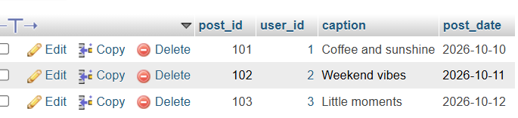
Task 2:
Write an SQL query using INNER JOIN to display each post's caption along with the name of the influencer who posted it, based on the tables you created.
Query

SELECT posts.caption, influencers.name
FROM posts
INNER JOIN influencers
ON posts.influencer_id = influencers.influencer_id;
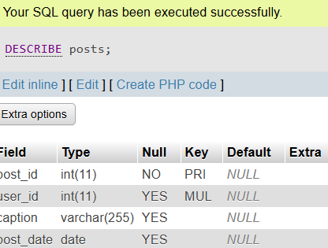
Task 3:
Write an SQL query using LEFT JOIN to show all influencers and their posts, including influencers who haven't posted anything yet. If an influencer has no posts, display 'No Posts' in the caption column.<br><br><em><strong>Hint:</strong> Use IFNULL or COALESCE to handle NULL values in the result.</em>
Query

DESCRIBE posts;
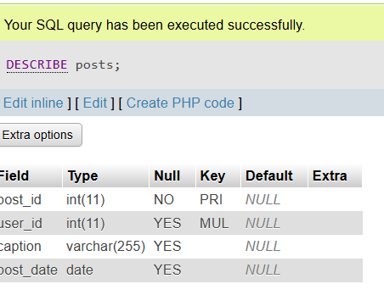
Task 4

Write an SQL query using RIGHT JOIN to list all posts and the corresponding influencer's name, ensuring that even posts without a matching influencer_id (if any) are shown.
Query

SELECT
posts.post_id,
posts.caption,
influencers.name
FROM influencers
RIGHT JOIN posts
ON influencers.influencer_id = posts.influencer_id;


